A Project Report

*On*

College Predictor Website

*By*

Akshay Dongare (TC219)

Resham Dharia (TC218)

Yash Dagadkhair (TC213)

*Under the guidance of*

Mrs. Jagruti Wagh



**Department of Computer Engineering**

**Marathwada Mitra Mandal’s College of Engineering**

**SAVITRIBAI PHULE PUNE UNIVERSITY**

**2022-2023**

| Marathwada Mitra Mandal’s College of Engineering  Department of Computer Engineering,Pune_51 |  |
| --- | --- |



Date:

**CERTIFICATE**

This is to certify that,

Akshay Dongare (TC219)

Resham Dharia (TC218)

Yash Dagadkhair (TC213)

of class T.E Computer have successfully completed their project work on “College Predictor Website’ at MARATHWADA MITRA MANDALS COLLEGE OF ENGINEERING in the partial fulfillment of the Graduate Degree course in T.E Web Technology Subject at the Department of Computer Engineering, in the academic Year 2022-2023 Semester – II as prescribed by the Savitribai Phule Pune University.

Mrs. Jagruti Wagh Prof KS Thakre

Guide Head of the Department

(Department of Computer Engineering)

**Acknowledgement**

I feel great pleasure in expressing my deepest sense of gratitude and sincere thanks to my guide Mrs. Jagruti Wagh for her valuable guidance during the Project work, without which it would have been a very difficult task. I have no words to express my sincere thanks for valuable guidance, extreme assistance and cooperation extended to all the **Staff Members** of my Department.

This acknowledgement would be incomplete without expressing my special thanks to **Prof.** KS Thakre, Head of the Department (Information Technology) for their support during the work.

I would also like to extend my heartfelt gratitude to my **Principal, Dr. V N Gohokar** who provided a lot of valuable support, mostly being behind the veils of college bureaucracy.

Last but not least I would like to thank all the Teaching, Non- Teaching staff members of my Department, my parents and my colleagues who helped me directly or indirectly for completing this Project successfully.

Akshay Dongare (TC219)

Resham Dharia (TC218)

Yash Dagadkhair (TC213)

**Contents**

1. **TITLE OF PROJECT**
2. **ABSTRACT**
3. **INTRODUCTION**
   1. Problem definition
4. **SCOPE**
5. **SPECIFIC REQUIREMENTS**
   1. Hardware Interface
   2. Software Interface
6. **THEORY OF SOFTWARE USED**
   1. Java (JDK)/NETBEANS
   2. MYSQL
7. **ER DIAGRAM**
8. **SCHEMA DIAGRAM**
9. **DATABASE TABLE FORMAT**
10. **OUTPUT SCREEN (GUI)**
11. **SAMPLE CODE**
12. **CONCLUSION**
13. **REFERENCES**

**TITLE OF PROJECT**

College Predictor Website

**ABSTRACT**

The College Predictor Website project aims to help high school students and their parents in the college selection process by providing personalized recommendations based on their academic performance, financial background, and other preferences. The website uses web technologies such as HTML, CSS, and JavaScript to create an interactive and user-friendly interface. The project also involves integrating data from various sources, such as college databases and financial aid calculators, to provide accurate and up-to-date information. The website's algorithm analyzes the data and generates a list of recommended colleges, along with detailed information on admission requirements, tuition fees, and other relevant factors. Overall, the College Predictor Website project seeks to simplify the college selection process and empower students to make informed decisions about their future.

**INTRODUCTION**

1. **Problem Definition**

Selecting the right college can be overwhelming, especially for high school students who are often unaware of the many factors that need to be considered. There is a vast amount of information available on the internet, including college rankings, admission requirements, and tuition fees, but it can be challenging to navigate and make sense of all this information. This can lead to a lack of confidence in decision-making, resulting in poor college choices that can impact students' academic and career goals. The College Predictor Website project addresses this problem by providing a comprehensive, user-friendly platform that helps students and their parents make informed choices and select the right college that meets their unique needs.

The process of selecting the right college can be daunting for high school students and their parents. With thousands of institutions to choose from, each with its own unique features and requirements, it can be difficult to know where to begin. That's where the College Predictor Website project comes in. Using web technologies, this project aims to simplify the college selection process by providing personalized recommendations based on a student's academic performance, financial background, and other preferences. The website will analyze data from various sources to generate a list of recommended colleges, along with detailed information on admission requirements, tuition fees, and other relevant factors. With this website, we hope to empower students to make informed decisions about their future and help them achieve their educational goals.

**SCOPE**

The scope of the College Predictor Website project is to create a user-friendly web-based application that streamlines the college selection process for high school students and their parents.

The project will involve developing a visually appealing and interactive interface using web technologies such as HTML, CSS, JavaScript and PHP.

The website will integrate data from multiple sources such as college databases, financial aid calculators, and student academic records to provide accurate and personalized recommendations.

The algorithm will analyze the data to generate a list of recommended colleges based on a student's academic performance, financial background, and other preferences.

Additionally, the website will provide detailed information on admission requirements, tuition fees, and other relevant factors to help students make informed decisions about their future.

Overall, the project aims to simplify the college selection process and empower students to make well-informed decisions that align with their academic and career goals.

**SPECIFIC REQUIREMENTS**

**Hardware Interface**:

- A computer with a minimum of 4GB RAM and a dual-core processor

- An internet connection for testing and deployment

- A monitor with a minimum resolution of 1024x768 pixels

- The computer used for development should have enough available hard drive space to store the project files, database, and other necessary software.

- Graphics Card: A dedicated graphics card is not necessary for this project. However, a graphics card with at least 1 GB of video memory can help improve the performance of the web development tools and allow for smoother rendering of graphics and animations.

**Software Interface**:

- Operating System: Windows 10 or Ubuntu 20.04 LTS

- XAMPP 7.4.19 for Windows or Linux (includes Apache web server, MySQL database, PHP, and Perl)

- Google API console account for Google Authentication integration

- Text editor for coding (e.g. Visual Studio Code)

- Web browser for testing and debugging (e.g. Chrome, Firefox, or Safari)

**Versions**:

- PHP 7.4.19

- MySQL 8.0.25

- XAMPP 7.4.19

- Google Maps API v3

- HTML5

- CSS3

- JavaScript ES6

**Note:**

The specific hardware and software requirements may vary based on the scale and complexity of the project. These requirements are intended to serve as a general guideline for a small to medium-sized project.

**THEORY OF SOFTWARE USED**

Here is a list of the software used in the College Predictor Website project along with their theoretical basis:

1. PHP - PHP is a server-side scripting language that is used to create dynamic web pages. It allows web developers to create applications that can interact with databases, handle form data, and generate HTML content dynamically.

2. MySQL - MySQL is a relational database management system that is used to store and retrieve data for web applications. It is open-source software and provides a robust, scalable, and secure platform for data management.

3. Google API - Google API is a set of application programming interfaces provided by Google. These APIs allow developers to integrate Google services, such as Google Maps, into their web applications. This enables users to interact with the web application in new and useful ways.

4. XAMPP - XAMPP is an open-source software package that provides a local web server environment for developing and testing web applications. It includes Apache, PHP, MySQL, and other tools that are required for web development.

5. CSS - CSS stands for Cascading Style Sheets and is used to control the visual appearance of web pages. It allows web developers to separate the content and presentation of web pages, making it easier to maintain and update the website's design.

6. HTML - HTML stands for Hypertext Markup Language and is used to create the structure and content of web pages. It provides a set of tags that define the elements of a web page, such as headings, paragraphs, images, and links.

7. JavaScript - JavaScript is a client-side scripting language that is used to add interactivity and dynamic functionality to web pages. It allows web developers to create animations, validate form data, and interact with web services in real-time.

**ER DIAGRAM**

**SCHEMA DIAGRAM**

**DATABASE TABLE FORMAT**

mysql> desc usertable;

+----------+--------------+------+-----+---------+----------------+

| Field | Type | Null | Key | Default | Extra |

+----------+--------------+------+-----+---------+----------------+

| Id | int | NO | PRI | NULL | auto_increment |

| Username | varchar(100) | NO | | NULL | |

| Password | varchar(100) | NO | | NULL | |

+----------+--------------+------+-----+---------+----------------+

3 rows in set (0.03 sec)

mysql> select * from usertable;

+----+----------+--------------+

| Id | Username | Password |

+----+----------+--------------+

| 1 | testuser | testpassword |

| 2 | Akshay | Akshay |

+----+----------+--------------+

2 rows in set (0.00 sec)

**OUTPUT SCREEN (GUI)**

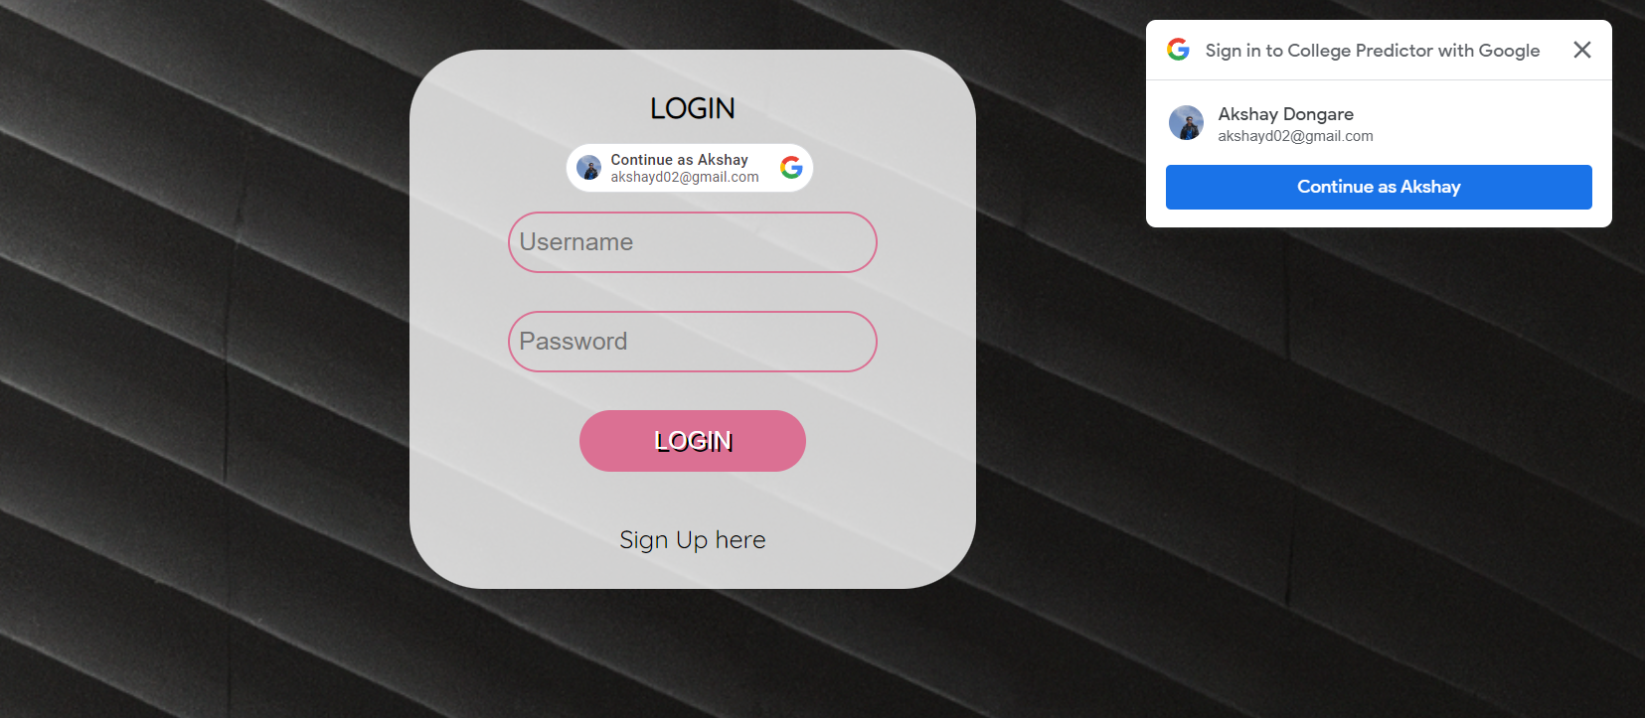

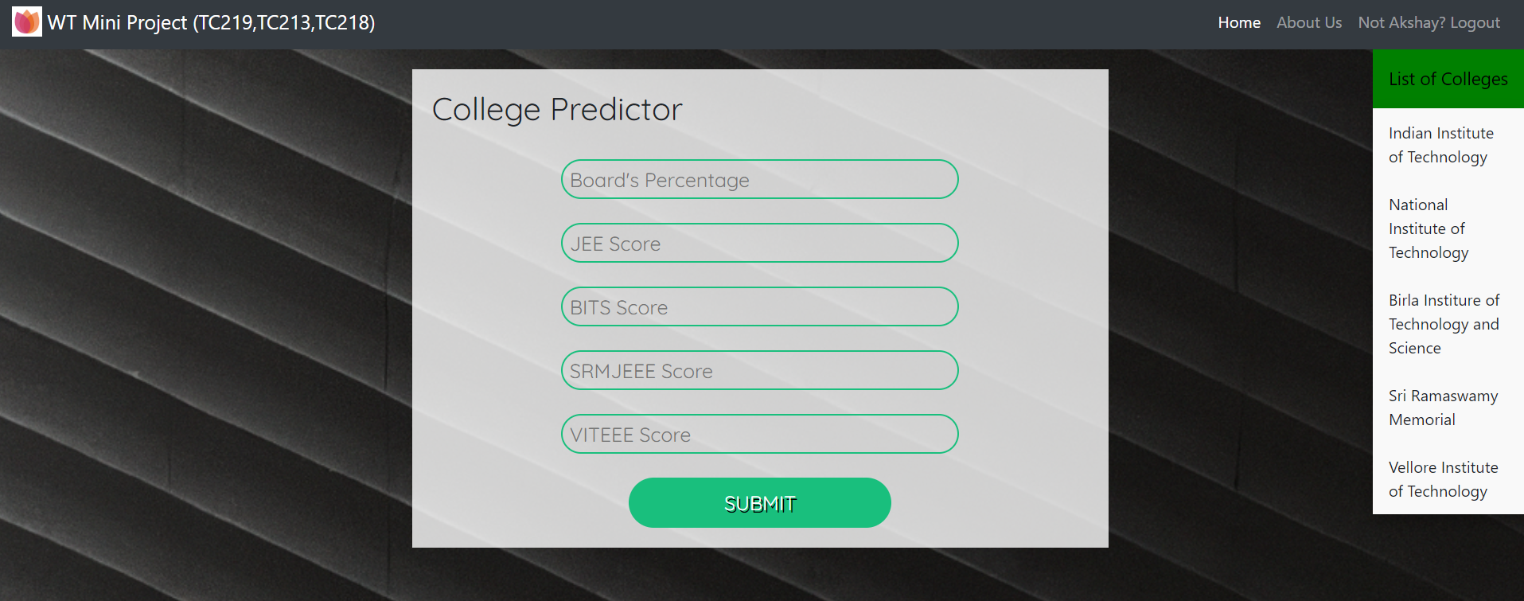

**SAMPLE CODE**

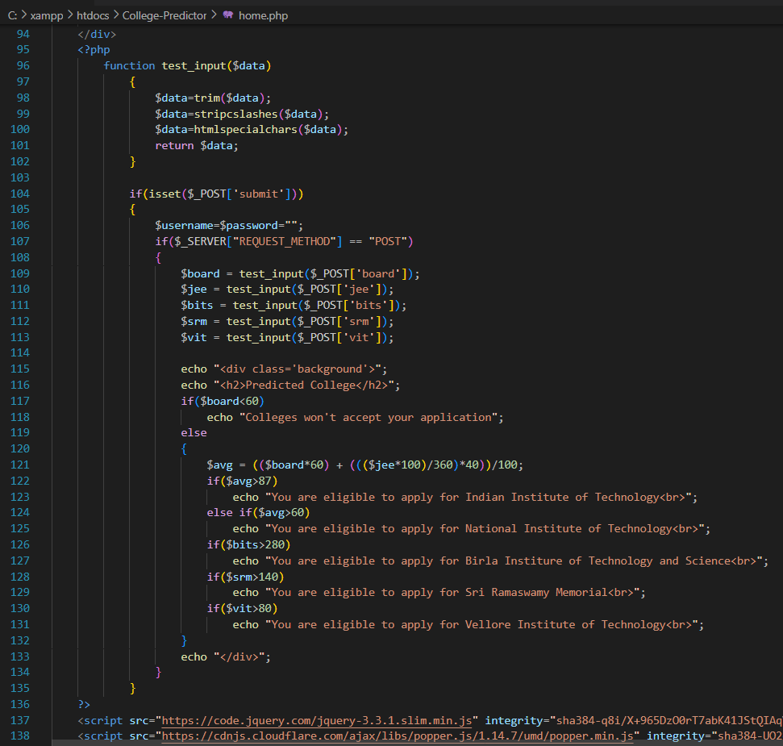

**CONCLUSION**

In conclusion, the College Predictor Website project is an innovative and valuable tool that simplifies the college selection process for high school students and their parents. With its user-friendly interface, personalized recommendations, and comprehensive information on colleges, this project aims to empower students to make informed decisions about their future. The project's use of web technologies such as HTML, CSS, and JavaScript makes it accessible to a wide audience and ensures that the website is interactive and visually appealing. By integrating data from multiple sources, the project provides accurate and up-to-date information on admission requirements, tuition fees, and other relevant factors, giving students a clearer picture of their college options. Overall, the College Predictor Website project offers an effective solution to the challenges faced by high school students in selecting the right college and provides a valuable resource for their academic and career success.

**REFERENCES**